a Fatigue Penalty Model for xG

does fatigue affect the quality or quantity of shots taken.

**Abstract**

The increasing density of elite football schedules has raised concern regarding the extent to which accumulated fatigue influences technical and tactical performance. While the physiological effects of fatigue have been extensively studied, its direct impact on footballing outcomes such as shot production and quality remains underexplored, largely due to historical data limitations. This study presents a quantitative analysis of the relationship between player workload and shot performance using event and physical tracking data from approximately 61,000 non-penalty shots across 2,340 men’s matches in the English Premier League, German Bundesliga, and Spanish La Liga during the 2023/24 and 2024/25 seasons.

Player fatigue was operationalised via an Acute:Chronic Workload Ratio (ACWR), defined as the ratio between short-term (1-week) and long-term (4-week) distance-weighted running metrics that account for movement intensity. Shot-level analyses were conducted at both the individual and team levels to examine associations between fatigue and (i) shot volume, (ii) shot quality measured by expected goals (xG), and (iii) shot conversion efficiency.

Results reveal a statistically significant but modest negative association between team-level fatigue and shot volume (p < 0.05, R² = 0.12), corresponding to an estimated decrease of approximately three shots per game for each unit increase in ACWR. A weaker, borderline significant relationship (p = 0.08, R² = 0.001) was observed between team fatigue and average shot xG, suggesting a limited reduction in the creation of high-quality shooting opportunities under conditions of elevated workload. No significant associations were identified when analyses were restricted to the fatigue levels of the shooting player alone.

These findings indicate that fatigue exerts only a minor influence on shot-related performance at the elite level, potentially reflecting effective workload management and recovery practices in contemporary professional football. Nevertheless, the approach outlined provides a framework for integrating physical tracking data with performance outcomes and may inform future research into the cumulative and contextual effects of fatigue on match performance.

Introduction

Top level footballers play more games than ever, In the most recent season Chelsea’s season ran from August 18th 2024 to July 13th 2025: their first preseason game was August 8th

At the same time player performance is closely monitored, for many years players have worn GPS trackers, now this information can also be captured using computer vision for every player in every game.

The plot below shows the weekly fatigue of Bayern Munich (red) and Bayer Leverkusen (black) in the 23/24 where Leverkusen famously won the title. There were large spikes for Munich before critical games v Leverkusen due to competitive early season games (German Super Cup) and refixed December games, before the 3 nil loss in February.

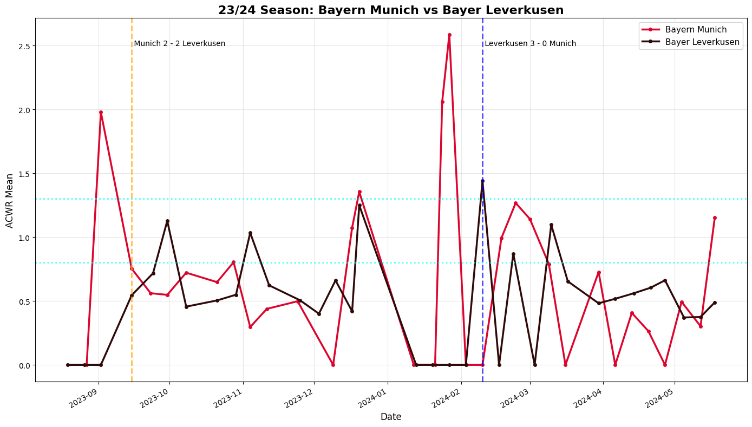

While there has been lots of work to quantify and the physical affect of fatigue only recently has there been available enough data to quantify a football effect of fatigue.

With this paper I aim to quantify the effect of fatigue on shots, either in terms of the quality of shots (measured in Expected Goals xG), conversion of shots into goals, or the volume of shots. I look at this both in terms of the shooting player and the entire shooting team.

Related Work

In deriving a measure of workload I attempted to re-engineer the Statsport (GPS Data provider) metric High Metabolic-Load Distance (HMLD) however this metric includes distance accelerating and decelerating so other metrics were required.

Look at papers you saved especially ACWR Bucket and Dave Clarks

Data

This study draws on a large-scale dataset combining event and physical tracking data across top-tier European men’s football. The final dataset contains approximately **61,000 non-penalty shots** from **2,340 matches** spanning three major domestic leagues over two seasons (2023/24–2024/25):

|  |  |  |  |
| --- | --- | --- | --- |
| Competition | Country | 23/24 | 24/25 |
| Bundesliga | Germany | **✔** | **✔** |
| Premier League | England | **✔** | **✔** |
| La Liga | Spain |  | **✔** |

**Event Data and Physical Metrics**

For each shot, event-level data were linked with a set of **in-game physical metrics** derived from tracking data. These metrics capture player workload through counts and distances associated with different movement intensities. The following variables were available:

* Count and Distance for High-Intensity (HI) actions
* Count and Distance for High-Speed Running (HSR)
* Count and Distance for Sprinting actions
* Count and Distance for Medium-Intensity Accelerations and Decelerations
* Count and Distance for High-Intensity Accelerations and Decelerations
* Total Distance covered
* Running Distance (15–20 km/h)
* HSR Distance (20–25 km/h)
* Sprinting Distance (>25 km/h)
* Maximum Speed (km/h)
* Distance per minute (m/min)

Physical metrics were aggregated at multiple temporal resolutions: by **half**, by **full match**, and in **15-minute segments** (e.g., 0–15, 15–30, etc.), enabling analysis of both acute and accumulated workload within games.

**Shot-Level Data Construction**

For each non-penalty shot, physical workload metrics were compiled for both the **shooting player** and all **teammates on the field** at the time of the shot. Metrics were aggregated over three within-match windows:

1. The 15 minutes preceding the shot,
2. The current half up to the shot time, and
3. The full match up to the shot time.

In addition, rolling workload measures were computed over historical time windows of **1 week**, **2 weeks**, and **4 weeks**, allowing the derivation of acute and chronic workload ratios used to quantify fatigue.

**Data Augmentation and Imputation**

Because complete tracking coverage is not available for all competitions, additional workload estimates were generated to fill gaps:

* For **European and domestic cup matches**, workload was estimated proportionally to minutes played. For example, a player averaging 10 km of total distance per 90 minutes and playing 45 minutes in a match was allocated 5 km of workload for that fixture.
* For **international fixtures**, where detailed lineup and tracking data are unavailable, each player was assigned an estimated 45 minutes of “regular intensity” match activity for each fixture during an international window. Although this assumption simplifies real-world variability, it ensures that the international workload typical of elite players is captured in cumulative fatigue measures.

**Fatigue Quantification**

Player fatigue was quantified using a **custom metric**, based on best practice, designed to approximate the physiological load associated with varying running intensities. The schema utilised the following Wyscout movement categories:

|  |  |  |
| --- | --- | --- |
| Basis | Speed (kmph) | Wyscout Metric |
| Distance in Kilometres | 20 – 25 | HSR Distance |
| Distance in Kilometres | 25< | Sprinting Distance |
| Count |  | High Speed Accelerations |
| Count |  | High Speed Decelerations |

All variables were normalized and carry equal weight.

Methodology

Association Football/ Soccer is a game played with the feet and based on running, there are few collisions and uses of the upper body are rare enough such that the primary workload is running based: top level players can average 10 kilometres per game.

I used an Acute/ Chronic Workload Ratio (ACWR) to measure fatigue. ACWR is recommended by International Olympic Committee in measuring workload. I used an Acute/ Chronic Workload Ratio (ACWR) to measure how much work load in the last 7 days differed from the average workload over the last 4 weeks, measured as 1 week metric / 4 week metric/4.

The plot below shows the percentage of shots taken in each bucket of ACWR

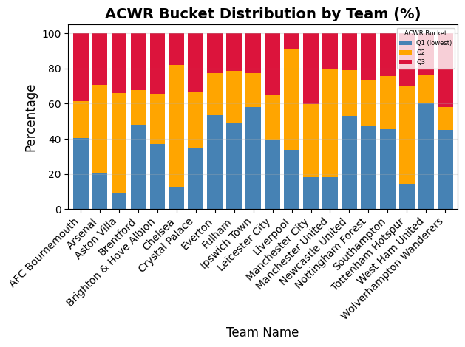

Results

There is one result of note, on team based metrics:

There is a statistically significant relationship between shot volume (the number of shots at goal taken) and fatigue however a low correlation value indicates that this explains very little of the variation (p=0, R2 =0.12) indicating reduction of 3 shots per game per unit of ACWR added. On average as the bucket of ACWR decreases the number of shots taken by a team increases by one.

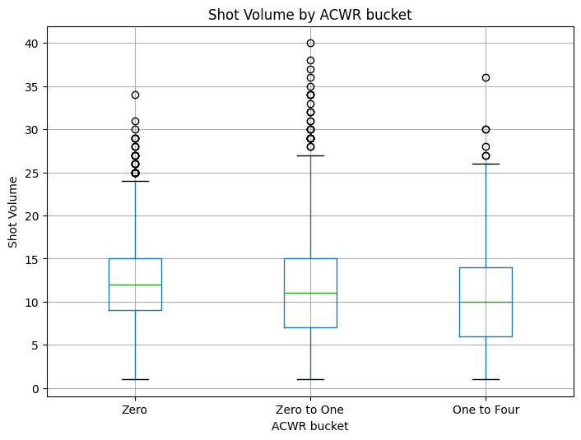

Obviously these are minor results and in general there seems to be little link between shooting performance and fatigue.

Applications

Limitations and Future Direction

While this study identifies some limited relationships between fatigue and shot-related performance, several caveats should be noted regarding the data, assumptions, and scope of analysis.

First, the dataset covers only in-game physical metrics and omits training load, which constitutes a substantial portion of overall player workload. Professional clubs typically monitor and adjust training intensity in response to fixture congestion, so the absence of training data likely reduces the observable variation in fatigue. In effect, teams with higher match loads may compensate through modified training regimens, masking stronger underlying relationships.

Second, all data were collected in the era of five substitutions per match. The expanded substitution rule has been shown to mitigate the impact of acute fatigue by allowing coaches to manage workloads dynamically within matches. Similarly, rolling squad rotation and load management strategies mean that players with extreme fatigue levels are less likely to be fielded, further diminishing measurable effects.

Third, the study assumes that physical metrics derived from match tracking data accurately represent exertion. However, factors such as tactical role, opposition style, and match context (e.g., game state or scoreline) influence running profiles independently of fatigue. For example, players in possession-dominant teams or those defending deep may record lower high-intensity distances without being less fatigued. The model does not explicitly control for these contextual tactical variables.

Fourth, estimation methods were necessary for matches without full physical tracking coverage—especially for international fixtures and domestic cup competitions. Although reasonable assumptions were made (e.g., assigning typical running loads for partial minutes or international play), these imputations inevitably introduce noise and potential bias into the workload calculations.

Finally, the analysis focuses exclusively on regulation-time league matches. Knockout fixtures and games involving extra time likely generate more extreme fatigue conditions, which may reveal stronger effects on shot creation or quality. Similarly, this work does not distinguish between positional groups or playing styles, both of which may moderate the relationship between fatigue and performance.

Taken together, these limitations suggest that while the findings provide initial evidence on the minimal impact of fatigue on shot-level outcomes, the results should be interpreted with caution. Future work incorporating training data, tactical context, and positional differences, as well as extending to competitions with higher physical demands, may yield a more complete understanding of how cumulative workload influences football performance.